Chapter 8, Solution 37.

For the network in Fig. 8.85, solve for i(t) for t > 0.

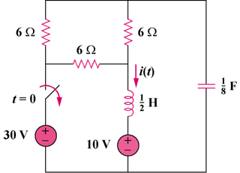

15 V

45 V

Figure 8.85
For Prob. 8.37.

Solution
For t = 0–, the equivalent circuit is shown below.

6 Ω

6 Ω

+

v(0)

−

i₁

i₂

45V

+
−

15V

+
−

6 Ω

18i₂ – 6i₁ = 0 or i₁ = 3i₂ (1)

–45 + 6(i₁ – i₂) + 15 = 0 or i₁ – i₂ = 30/6 = 5 (2)

From (1) and (2), (2/3)i₁ = 5 or i₁ = 7.5 and i₂ = i₁ – 5 = 2.5

i(0) = i₁ = 7.5A

–15 – 6i₂ + v(0) = 0

v(0) = 15 + 6x2.5 = 30

For t > 0, we have a series RLC circuit.

R = 6||12 = 4

ω_{o} = 1/ = 1/ = 4

- = R/(2L) = (4)/(2x(1/2)) = 4

- = ω_{o}, therefore the circuit is critically damped

v(t) = V_{s} +[(A + Bt)e^{-4t}], and V_{s} = 15

v(0) = 30 = 15 + A, or A = 15

i_{C} = Cdv/dt = C[–4(15 + Bt)e^{-4t}] + C[(B)e^{-4t}]

To find i_{C}(0) we need to look at the circuit right after the switch is opened. At this time, the current through the inductor forces that part of the circuit to act like a current source and the capacitor acts like a voltage source. This produces the circuit shown below. Clearly, i_{C}(0+) must equal –i_{L}(0) = –7.5A.

6 Ω

6 Ω

i_{C}
+

7.5A

6 Ω

30V

+
−

i_{C}(0) = –7.5 = C(–60 + B) which leads to –60 = –60 + B or B = 0

i_{C} = Cdv/dt = (1/8)[–4(15 + 0t)e^{-4t}] + (1/8)[(0)e^{-4t}]

i_{C}(t) = [–(1/2)(15)e^{-4t}]

i(t) = –i_{C}(t) = 7.5e^{-4t} A

